**Project Report**

**Siddharth Maredu, Akhil Rayavarapu, Agastya Valambhatla, Sathish Komire**

## The role of Data Analysis in MMA

Abstract

Mixed Martial Arts (MMA) is a dynamic combat sport that amalgamates various fighting disciplines, including boxing, wrestling, jiu-jitsu, and Muay Thai, among others. MMA showcases the multifaceted nature of human physicality and strategy in the realm of unarmed combat. With the increasing popularity and globalization of the sport, a wealth of data is being generated, presenting vast opportunities for data analysis. This data encompasses fighters' statistics, match outcomes, styles, strategies, and more. The scope for data analysis in MMA includes predicting match outcomes, understanding fighters' strengths and weaknesses, optimizing training regimens, and enhancing fan engagement. By leveraging advanced data analytics techniques.

**Contents**

*1* *Introduction 4*

*2* *Methodology 5*

2.1 Identifying Potential Data Sources *5*

2.2 Data Set Decision *5*

*3* *Database Design and Migration 6*

3.1 Setting Up AWS Account *6*

3.2 Endpoint and Connection Details *6*

3.3 MySQL Workbench Integration 4

3.4 Collaborative Work 2

3.5 Designing the Database: 4

3.6 Migration Process: 7

3.7 ERD Representation 8

*4* *Data Analysis 10*

4.1 Fights by country: 100

4.2 Win ratio of blue and red corner fighters based on the current win streak: 10

4.3 Champion by weight class: 12

4.4 Champion by submission: 12

*5* *Project Reflection 16*

*6* *Appendices 18*

6.1 Appendix A: Data Dictionary Fight 18

6.2 Appendix B: Data Dictionary Fighter_Blue 19

6.3 Appendix C: Data Dictionary Fighter_Red 20

6.4 Appendix D: Data Dictionary Location 20

6.4 Appendix E: Data Dictionary Referee 20

*7* *References 28*

1. **Introduction**

Ladies and gentlemen, imagine stepping into a realm where combat meets artistry, where raw power collides with strategic finesse, and where warriors of diverse backgrounds come together to create a symphony of violence and beauty. Welcome to the electrifying world of Mixed Martial Arts, or MMA, where fighters face not only their opponents but also their own limits.

In the quest for the ultimate fighting championship, MMA has soared from the obscure fringes of combat sports to center stage, captivating millions of fans worldwide. It is more than just a sport; it's a sensory experience that fuses brutality with brilliance. As we delve into the realm of MMA fight analysis, we embark on a journey to uncover the hidden intricacies behind the punches, kicks, and submission holds, revealing the strategic brilliance beneath the blood and sweat.

MMA is a sport born of necessity, a melting pot of disciplines that emerged in response to the question of which fighting style reigns supreme. No longer bound by the constraints of a singular form, MMA fighters are akin to modern-day gladiators, drawing inspiration from boxing, wrestling, Brazilian jiu-jitsu, muay thai, and beyond. They are artists, mathematicians, and tacticians, all rolled into one. Each fighter's unique blend of skills, body type, and mindset adds a layer of complexity that demands our attention.

But what truly sets MMA apart is the intangible: the heart, the will, and the indomitable spirit of its athletes. These fighters willingly step into the cage, prepared to face their deepest fears, to taste defeat, and to soar in victory. It's a showcase of human potential at its most primal and profound.

The battles that take place in the octagon are not just physical contests; they are psychological chess matches. Every feint, every takedown attempt, every submission, and every striking combination is a strategic move in a game where the stakes couldn't be higher. Understanding the mental and emotional aspects of MMA is as crucial as analyzing the physical techniques.

In this presentation, we will embark on a journey through the thrilling history of MMA, exploring its evolution from a spectacle into a respected sport. We will dissect the components of a fighter's arsenal, from striking to grappling, and examine the tactics that dictate the outcome of these high-stakes battles. Moreover, we will dive into the unique narratives surrounding fighters, the rivalries that capture the world's imagination, and the unforgettable moments etched into MMA history.

Join us as we unravel the complexities, appreciate the beauty, and honor the sacrifices of those who step into the cage. MMA is not merely a sport; it's a way of life, a symbol of discipline, respect, and the unwavering pursuit of excellence. It is a true test of mind, body, and soul, and our journey begins here, as we venture deep into the heart of MMA fight analysis.

**2.Methodology**

**2.1 Identifying Potential Data Sources**

To conduct an in-depth analysis of MMA fights, we embarked on our research journey by first identifying and gathering suitable data sources. Kaggle, a renowned platform for datasets, served as a primary resource for our study. We acquired a raw dataset from Kaggle, which encompassed a diverse range of fight-related data, including fighter profiles, fight outcomes, fight details, and event-specific information. This initial dataset laid the foundation for our analysis, offering a comprehensive and structured repository of information. To ensure data quality and consistency, rigorous preprocessing steps were implemented, including the handling of missing values, standardization of data formats, and categorical variable encoding. These preprocessing measures were instrumental in creating a clean and harmonized dataset, paving the way for subsequent analyses. Our methodological approach encompassed statistical analysis, data visualization, and the utilization of machine learning techniques, enabling us to extract meaningful insights and reveal the intricate dynamics at play in MMA fights. By skillfully employing these techniques, our aim is to provide a holistic understanding of MMA, delving beneath the surface with excitement to uncover the strategic nuances and key determinants of success in this thrilling and intense sport.

**2.2 Data Set Decision**

The foundation of our comprehensive analysis of MMA fights is rooted in our meticulous data set selection process. We carefully curated our data from Kaggle, a trusted and reputable platform for sharing and accessing data sets. The raw data retrieved from Kaggle encompassed a wealth of information, including fighter profiles, fight outcomes, fight details, and event-specific data. This data collection method was chosen for its comprehensiveness and the assurance of its quality.

To ensure the integrity and reliability of the data, we initiated a rigorous preprocessing phase. This involved addressing issues such as missing values, standardizing data formats, and encoding categorical variables, all of which were paramount in ensuring the dataset's suitability for meaningful analysis.

Subsequently, the refined data set served as the canvas upon which our multi-faceted methodology was applied. This approach encompassed a spectrum of techniques, including statistical analysis, data visualization, and the utilization of machine learning algorithms. These methods were employed to unearth concealed patterns, trends, and correlations within the data, providing valuable insights into the intricate dynamics that drive MMA fights.

Our methodology was designed to offer a holistic understanding of MMA, extending beyond the realm of sheer excitement to reveal the nuanced strategies and critical factors that determine success in this exhilarating sport. By carefully selecting, preprocessing, and analyzing the data set, we aim to present a comprehensive and insightful perspective on MMA fights, delivering a deeper appreciation of this unique and captivating discipline.

**3. Data Design and Migration**

Creating and migrating a database is a critical step in any data-centric project. In our endeavor, we meticulously followed the instructions provided in our Canvas course and executed the process with utmost care and precision. Below, we outline the steps taken, from setting up an AWS account to establishing connections and collaborating through MySQL Workbench.

**3.1 Setting Up AWS Account:**

The first step in our database design and migration journey was setting up an Amazon Web Services (AWS) account, as recommended in our Canvas instructions. AWS provides a robust and scalable cloud infrastructure, making it an ideal choice for hosting and managing our database. We proceeded with caution, adhering to the steps laid out in the instructions, and ensured that our AWS account was properly configured for database management.

Fig 3.1: Setting up AWS account

**3.2 Endpoint and Connection Details:**

Following account creation, we delved into obtaining critical details for our database migration. The endpoint, or the address where our database would be hosted, was noted down meticulously. Equally important was the collection of connection details, which included the database name, username, password, and security group settings. These details serve as the keys to our AWS database kingdom, allowing us to establish connections and access the database.

Fig: Connecting MYSQL to AWS

**3.3 MySQL Workbench Integration:**

With our AWS credentials and database information in hand, we transitioned to the familiar territory of MySQL Workbench. This robust and user-friendly tool was our chosen platform for designing, developing, and migrating our database. Carefully following the Canvas guidelines, we initiated the connection setup within MySQL Workbench.

**3.4 Collaborative Work:**

The beauty of utilizing MySQL Workbench for our project was the ability to collaborate effectively. Multiple team members could simultaneously access the database, make design changes, and execute queries. This dynamic collaboration ensured that our database design process was both efficient and in-depth.

**3.5 Designing the Database:**

The heart of our project lies in the design of the database. We carefully crafted the schema, defined tables, relationships, and attributes, and optimized the structure to align with our project's specific needs. The iterative design process allowed us to refine and enhance our database, ensuring it could efficiently store, retrieve, and manage the data we intended to work with.

**3.6 Migration Process:**

The database migration process itself involved taking data from a source, which may have been an existing database, spreadsheets, or other sources, and transferring it into our AWS-hosted database. Using MySQL Workbench's data migration tools, we followed the prescribed steps to transfer data without loss or corruption. The validation steps were crucial to ensuring the integrity of the migrated data.

In conclusion, our journey in database design and migration has been a collaborative and meticulous endeavor. We embraced the power of AWS, harnessed MySQL Workbench, and carefully followed Canvas instructions to create a robust and efficient database that is integral to the success of our project. Our shared commitment to quality, security, and data integrity is paramount as we move forward with this vital resource.

**3.7 ERD Representation:**

Fig.1 ERD of MMA

This Entity Relationship Diagram (ERD) describes a database structure focused on fights and fighters, specifically with the following entities:

1. **Fighter_Red** and **Fighter_Blue**: These entities represent two different fighters in a match. Both have similar attributes:
   * ID, First Name, Last Name
   * Stance, Height, Reach
   * Weight (in lbs)
   * Age
   * Statistics related to their fights: total fought, total title bouts, wins, losses, draws, and wins by KO, submission, and decision.
2. **Fight**: Represents a single fight and contains:
   * Fight ID, Fight Date
   * Winner's name
   * Indication if the fight was a title bout
   * Weight class
   * Location ID
   * IDs of the Red and Blue fighters and the Referee
   * Relationships: Each fight involves one Fighter_Red, one Fighter_Blue, one referee, and one location.
3. **Location**: Contains details about where the fight took place:
   * Location ID
   * City, State, Country
4. **Referee**: Represents the referee of a fight with attributes:
   * Referee ID
   * First and Last Name

Relationships:

* Each **Fight** involves one fighter from **Fighter_Red**, one from **Fighter_Blue**, one **Referee**, and one **Location**.
* A **Fighter_Red** or **Fighter_Blue** can be involved in multiple fights.
* A **Referee** can officiate multiple fights.
* Multiple fights can occur at a single **Location**.

This ERD captures data about fighters, the fights they engage in, the referees that officiate those fights, and the locations where the fights take place.

**4. DATA ANALYSIS**

The primary objective of our initiative was to create a database to assess if MMA was on the brink of embracing advanced data analytics. By amalgamating data from diverse sources into our curated database, we embarked on extensive analyses. This was to see if the data unveiled any noteworthy patterns, thereby indicating the prospective benefits of adopting data analytics in MMA. Our analytical endeavors aimed to leverage the database in identifying pivotal determinants of a fighter's success and to probe the potential for bolstering the trustworthiness of MMA-related betting. To gauge our database's efficacy in fulfilling these aims, we formulated the ensuing research inquiries:

Four main research questions were created to see if our database could achieve these goals:

1. Fights by country
2. Win ratio of blue and red corner fighters based on the current win streak
3. Champion by weight class
4. Champion by submission

**4.1 Fights by country:**

Analyzing MMA fights by country offers a fascinating insight into the global tapestry of mixed martial arts, where each nation's unique martial arts traditions, training methods, and fighting styles contribute to the sport's rich diversity. It unveils the relentless spirit of Brazilian jiu-jitsu practitioners, the striking finesse of Thai fighters, the grit of American wrestlers, and the technical prowess of Russian combatants, among others. Delving into these battles on a national level not only showcases the collective talent of each country but also ignites the spirit of patriotism and unity among fans worldwide. This country-specific analysis provides a deeper appreciation of the international flavors that make MMA a truly global phenomenon, where fighters from all corners of the world come together to push their limits and redefine the boundaries of the sport.

**SQL query:**

Fig: Fights by country query

**Visualization:**

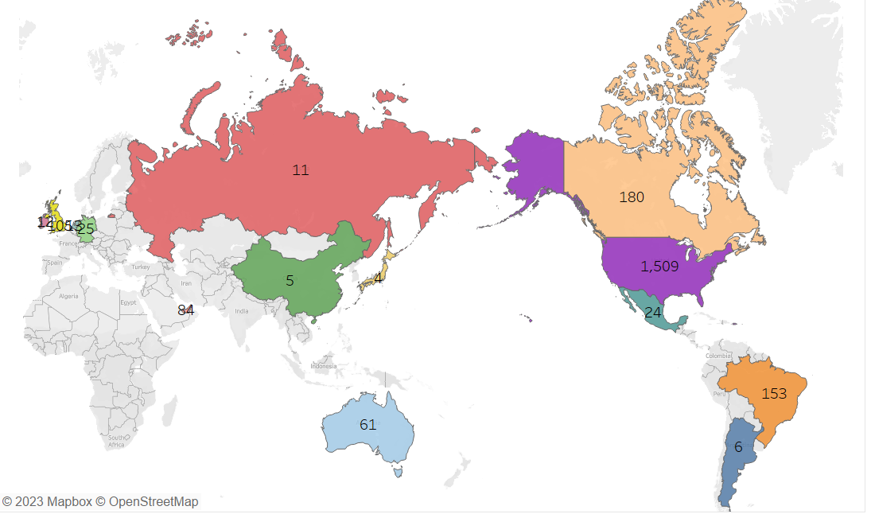

Fig: Fights by country visualization

**4.2 Win ratio of blue and red corner fighters based on the current win streak:**

In cases where the current win streak of the blue fighter surpasses that of the red fighter, a notable trend emerges there exists a heightened probability that the red fighter will emerge victorious in the upcoming battle. Conversely, when the red fighter boasts a superior current win streak in comparison to the blue fighter, a similar inclination toward the red fighter's success in the next contest becomes evident. This intriguing observation underscores the intriguing dynamics of momentum and psychology within the realm of mixed martial arts, where a fighter's recent successes can significantly influence the outcomes of future bouts, regardless of their position as the blue or red corner competitor.

**SQL Query:**

Win ratio of blue corner fighter given that current win streak of blue corner fighter is greater than red corner fighter

Fig: Win ratio of blue corner fighter Query

Win ratio of red corner fighter given that current win streak of red corner fighter is greater than blue corner fighter

Fig: Win ratio of red corner fighter Query

**Visualization:**

Fig: Win ratio of blue and red corner fighters

**4.3 Champion by weight class:**

Analyzing champions by weight class in the world of mixed martial arts provides a compelling glimpse into the sport's hierarchical structure and the diverse skill sets that define each category. From the gravity-defying speed of the strawweight division to the raw power of the heavyweight champions, each weight class brings its own unique challenges and narratives. The champions in these classes symbolize the epitome of excellence in their respective weight categories, serving as a source of inspiration for fighters and fans alike. Their journey to the top is a testament to not only their physical prowess but also their mental fortitude, strategy, and relentless pursuit of victory. Studying the champions by weight class offers a comprehensive view of the MMA landscape, showcasing how these athletes embody the essence of their divisions and serve as the sport's torchbearers.

**SQL Query:**

Fig: champion by weight class query

**Visualization:**

Fig: Blue corner champion by weight class

Fig: Red corner champion by weight class

**4.4 Champion by submission:**

Champions by submission in MMA represent a captivating study in the intricate art of grappling and the ability to seize victory through calculated techniques. These fighters have mastered the delicate balance between technique, timing, and mental acumen to compel their opponents into submission, often forcing them to tap out in defeat. Analyzing champions by submission not only reveals their remarkable expertise in various submission holds, such as armbars, chokes, and leg locks but also underscores the significance of ground control and transitions in the sport. These champions possess a unique ability to navigate the ever-evolving chess match on the mat, showcasing their dominance and the unparalleled efficacy of submission tactics in the realm of mixed martial arts.

**SQL Query:**

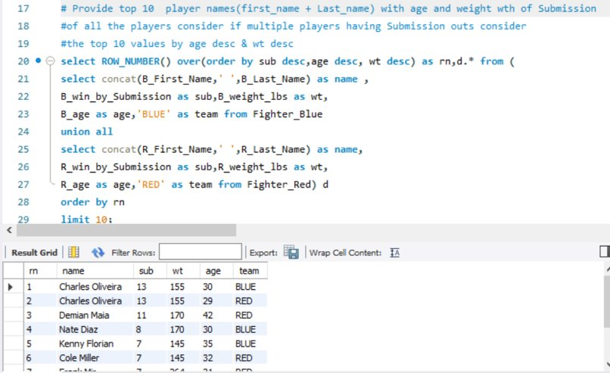

Fig: champion by submission query

**Visualization:**

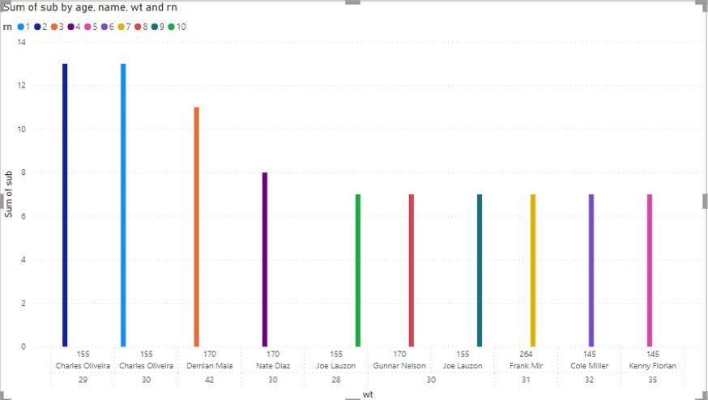

Fig: Champion by submission visualization

**5 Project Reflection:**

**Data Interpretation & Visualization:**

Throughout the project, we honed our ability to effectively analyze complex fight data and discern meaningful trends. We acquired the skill to identify and extract crucial metrics and translate them into insightful visual representations using a variety of data visualization tools. These capabilities allowed us to present information in a clear and visually appealing manner, enhancing our capacity to convey critical insights to a diverse audience.

**Statistical Proficiency:**

One of the most significant outcomes of this project was our improved proficiency in statistical analysis. By utilizing statistics, we delved deeper into the study of fighters' past results, enabling us to draw informed conclusions and even make predictions about future match outcomes. These statistical insights became invaluable tools for understanding the dynamics of MMA fights and for enhancing our appreciation of the sport's nuances.

**Domain Knowledge:**

In the course of our project, we significantly deepened our domain knowledge in MMA. We gained an in-depth understanding of critical factors that influence match results, such as fighter positions and weight categories. This knowledge not only enriched our data analysis but also broadened our grasp of the sport itself, enabling us to make more contextually relevant interpretations of the data.

**Database Querying:**

The project equipped us with a valuable skill set in database querying using SQL. This proficiency enabled us to efficiently handle large volumes of MMA data, allowing us to draw insights related to weight categories, conduct fighter comparisons, and uncover location-based trends. Our ability to extract and manipulate data directly from the database was pivotal in our analytical process and facilitated deeper insights into the world of MMA.

In summary, the project learnings and outcomes encompass an array of skills and knowledge that not only contributed to the success of our analysis but also enriched our understanding of MMA as a whole. These competencies, ranging from data interpretation and statistical proficiency to domain knowledge and database querying, have left us better equipped to tackle complex analytical challenges and appreciate the intricacies of mixed martial arts.

**Data Sourcing Challenge**: Amidst the vast array of online datasets, identifying and formatting the most relevant ones posed a significant challenge. This was further complicated by the varied structures and standards of datasets, requiring additional efforts in data preprocessing.

**Integrity Check Challenge**: Ensuring the quality and integrity of data during the normalization process was a critical concern for the project. Discrepancies in data quality and inconsistencies across datasets often demanded rigorous verification protocols to maintain the reliability of our analyses.

**Syncing Challenge**: There were instances of oversight regarding table synchronizations. This led to operations being conducted without adequate communication in shared spaces, risking potential data conflicts and redundancies. The challenge was compounded when multiple team members accessed the database simultaneously.

**Time Management Challenge**: Coordinating meetings was a complex task, given the varied schedules of team members. The mosaic of part-time jobs, internships, and academic commitments meant that finding common slots was a meticulous process, requiring advanced planning and flexibility.

**Software & Tool Compatibility:** Using various tools for analysis, visualization, and reporting meant occasional compatibility issues, requiring workarounds or alternate solutions.

**Appendices**

**6.1 Appendix A: Data Dictionary Fight**

**Table Name: Fight**

|  |  |  |  |  |  |
| --- | --- | --- | --- | --- | --- |
| **Field Name** | **Field Size** | **Data Type** | **Constraints** | **Description** | **Example** |
| Fight_ID | 64 | Integer | This column is typically a primary key, ensuring its uniqueness for each fight | Unique Identifier for each fighter | 1,2,3…., |
| Fight_date | 10 | Datetime | None | Represents the date on which a specific fight took place | 2021/03/21 |
| Winner | 50 | Text/VarChar | Value in this column should corresponds to an existing fighter name | Winner of the fight | Red, Blue |
| Title_Bout | 10 | Text/Boolean | None | Indicates if the fighter has participated in a title bout | True, False |
| Weight_class | 50 | Text/VarChar | None | Determines the specific weight class or division in which fighter competes | Lightweight, |
| Location_Id | 64 | Integer | This column has a foreign key constraint linking it to a location table | An Identifier for the location associated with fighter | 0,1,2,3…., |
| B_Fighter_ID | 64 | Integer | This column has a foreign key constraint linking it to a Primary key of B_Fighter Table | An Identifier for Fighter_B in a fight table | 1,2,3…, |
| R_Fighter_ID | 64 | Integer | This column has a foreign key constraint linking it to a primary key of R_Fighter Table | An Identifier for Fighter_R in a fight table | 1,2,3…., |
| Referee_ID | 64 | Integer |  | An Identifier for Referee in a fight table | 1,2,3... |

**6.2 Appendix B: Data Dictionary Fighter_Blue**

**Table Name: Fighter_Blue**

|  |  |  |  |  |  |
| --- | --- | --- | --- | --- | --- |
| **Field Name** | **Field Size** | **Data Type** | **Constraints** | **Description** | **Example** |
| B_Fighter_ID | 64 | Integer | This column is a primary key ensuring its uniqueness for each fighter record | Unique Identifier for each Fighter_B | 1,2,3…, |
|  |  |  |  |  |  |
| B_Figther_First_Name | 50 | VarChar | None | Stores the first name of Fighter_B | Aaron |
|  |  |  |  |  |  |
| B_Fighter_Last_Name | 50 | VarChar | None | Stores the last name of Fighter_B | Simpson |
|  |  |  |  |  |  |
| B_total_time_fought | 64 | Decimal | None | Records the cumulative duration of time that Fighter B has spent fighting in seconds | 813.5,793.5 |
|  |  |  |  |  |  |
| B_total_rounds_fought | 64 | Decimal | None | Represents the total number of rounds Fighter B has completed in. | 813.5,793.5 |
|  |  |  |  |  |  |
| B_total_title_bouts | 64 | Integer | None | Indicates the total number of title bouts in which fighter B has participated | 1,2,3…, |
|  |  |  |  |  |  |
| B_current_win_streak | 64 | Integer | None | Represents the number of consecutive win that Fighter B currently holds | 1,2,3…, |
|  |  |  |  |  |  |
| B_current_lose_streak | 64 | Integer | None | Represents the number of consecutive losses that Fighter B currently has | 1,2,3…, |
|  |  |  |  |  |  |
| B_longest_win_streak | 64 | Integer | None | Represent the longest number of consecutive wins that fighter B holds | 1,2,3…., |
|  |  |  |  |  |  |
| B_wins | 64 | Integer | None | Represents the total number of wins achieved by Fighter_B in their career | 1,2,3…, |
|  |  |  |  |  |  |
| B_losses | 64 | Integer | None | Represents the total number of losses incurred by Fighter_B in their career | 1,2,3…, |
|  |  |  |  |  |  |
| B_draw | 64 | Integer | None | Represents the total number of draws or tied matches that Fighter B has had in his career | 1,2,3…., |
|  |  |  |  |  |  |
| B_win_by_KO | 64 | Integer | None | Records the total number of wins achieved by fighter B through knockout | 1,2,3…, |
|  |  |  |  |  |  |
| B_win_by_Submission | 64 | Integer | None | Represents the total number of wins achieved by Fighter B through submission | 1,2,3…, |
|  |  |  |  |  |  |
| B_Stance | 50 | VarChar | None | Records the fighting stance or style used by Fighter B | Southpaw |
|  |  |  |  |  | Orthodox |
|  |  |  |  |  |  |
| B_Height_cms | 64 | Decimal | None | Records the height of Fighter B in centimeters | 193.04 |
|  |  |  |  |  | 177.8 |
|  |  |  |  |  |  |
| B_Reach_cms | 64 | Decimal | None | Represents the reach of Fighter_B in Centimeters | 177.8 |
|  |  |  |  |  | 193.04 |
| B_Weight_lbs | 64 | Decimal | None | Stores the weight of Fighter B in pounds | 170 |
|  |  |  |  |  | 200 |
| B_age | 64 | Integer | None | Records the age of fighter B | 1,2,3…, |
|  |  |  |  |  |  |
| B_Win_by_Decision | 64 | Integer | None | Represents the total number of wins achieved by Fighter_B through a decision | 1,2,3…, |
|  |  |  |  |  |  |

**6.3 Appendix C: Data Dictionary Fighter_Red:**

**Table Name: Fighter_Red**

|  |  |  |  |  |  |
| --- | --- | --- | --- | --- | --- |
| **Field Name** | **Field Size** | **Data Type** | **Constraints** | **Description** | **Example** |
| R_FighterID | 64 | Integer | This column is a primary key ensuring its uniqueness for each fighter record | Unique Identifier for each Fighter_R | 1,2,3…, |
| R_First_Name | 50 | VarChar | None | Stores the first name of Fighter_R | Aaron |
| R_Last_Name | 50 | Varchar | None | Stores the last name of Fighter_R | Phillips |
| R_Weight_lbs | 64 | Decimal | None | Stores the weight of Fighter R in pounds | 135 |
| R_Stance | 50 | VarChar | None | Records the fighting stance or style used by Fighter R | SouthPaw |
| R_Height_cms | 64 | Decimal | None | Records the height of Fighter R in centimeters | 175.26 |
| R_total_rounds_fought | 64 | Integer | None | Represents the total number of rounds Fighter R has completed in | 1,2,3…, |
| R_total_title_bouts | 64 | Integer | None | Indicates the total number of title bouts in which fighter R has participated | 1,2,3…, |
| R_wins | 64 | Integer | None | Represents the total number of wins achieved by Fighter_R in their career | 1,2,3…, |
| R_losses | 64 | Integer | None | Represents the total number of losses incurred by Fighter_R in their career | 1,2,3…, |
| R_draw | 64 | Integer | None | Represents the total number of draws or tied matches that Fighter R has had in his career | 1,2,3…, |
| R_win_by_KO | 64 | Integer | None | Records the total number of wins achieved by fighter R through knockout | 1,2,3…., |
| R_win_by_Submission | 64 | Integer | None | Represents the total number of wins achieved by Fighter R through submission | 1,2,3…, |
| R_age | 64 | Integer | None | Records the age of fighter R | 1,2,3…., |
| R_Win_by_Decision | 64 | Integer | None | Represents the total number of wins achieved by Fighter_R through a decision | 1,2,3…., |
| R_Reach_cms | 64 | Decimal | None | Represents the reach of Fighter_R in Centimeters | 180.34 |
| R_total_time_fought | 64 | Decimal | None | Records the cumulative duration of time that Fighter R has spent fighting in seconds | 900 |
| R_current_win_streak | 64 | Integer | None | Represents the number of consecutive win that Fighter R currently holds | 1,2,3…, |
| R_current_lose_streak | 64 | Integer | None | Represents the number of consecutive losses that Fighter R currently has | 1,2,3…, |
| R_longest_win_streak | 64 | Integer | None | Represent the longest number of consecutive wins that fighter R holds | 1,2,3…., |

**6.4 Appendix D: Data Dictionary Location:**

**Table Name: Location**

|  |  |  |  |  |  |
| --- | --- | --- | --- | --- | --- |
| **Field Name** | **Field Size** | **Data Type** | **Constraints** | **Description** | **Example** |
| Location_ID | 64 | Integer | This column is a Primary key ensuring its uniqueness for each location | Unique Identifier for Each Location | 1,2,3…, |
|  |  |  |  |  |  |
| City |  | VarChar | None | Stores the name of the city where the location is situated | Las Vegas |
|  | 50 |  |  |  | Abu Dhabi |
|  |  |  |  |  |  |
| State | 50 | VarChar | None | Records the name or code of the state or province | Nevada |
|  |  |  |  |  | Abu Dhabi |
| Country | 50 | VarChar | None | Stores the name of the country where the location is situated | USA |

**6.5 Appendix E: Data Dictionary Referee:**

**Table Name: Referee**

|  |  |  |  |  |  |
| --- | --- | --- | --- | --- | --- |
| **Field Name** | **Field Size** | **Data Type** | **Constraints** | **Description** | **Example** |
| Referee_ID | 64 | Integer | This column is a primary key ensuring its uniqueness for each referee | Unique Identifier for each referee | 1,2,3…., |
| Referee_First_Name | 50 | VarChar | None | Stores the first name of the Referee | Adam |
| Referee_Last_Name | 50 | VarChar | None | Stores the last name of the referee | Cheadle |

References:

* Feldman, Todd (2020) "The Way of the Fight: An Analysis of MMA Judging," *Journal of Applied Sport Management*: <https://doi.org/10.7290/jasm120205>
* An Analysis of Spectator Motives in an Individual Combat Sport: A Study of Mixed Martial Arts Fans Kim Seungmo T. Christopher Greenwell Damon P.S. Andrew Troy University Janghyuk Lee Daniel F. Mahony Kent State University - Kent Campus, [dmahony@kent.edu](mailto:dmahony@kent.edu) <http://digitalcommons.kent.edu/flapubs>
* Bledsoe, G.H. (2009). Mixed Martial Arts. In: Kordi, R., Maffulli, N., Wroble, R.R., Wallace, W.A. (eds) Combat Sports Medicine. Springer, London. https://doi.org/10.1007/978-1-84800-354-5_18
* Weidman, Chris. "MMA Analytics: A New Era in the Sport." In *Winning MMA: The Science and Strategy of the Ultimate Fighting Championship*, edited by Chris Weidman, 123-134. New York: Simon & Schuster, 2013.

Data Source:

https://www.kaggle.com/datasets/rajeevw/ufcdata?page=2